The Dangers of CTE

New Mexico
Supercomputing Challenge
Final Report
April 4, 2018

THS 131
Taos High School
Team Members:
Cyrus O’Hern
James Ryan Cox
Sawyer Solfest
Skylar Spriggs
Teacher:
Tracy Galligan
Project Mentors:
Andrew Leonard – Physics Advisor
Nick Bennett – Code Advisor
- an executive summary that is shorter than one page
- a statement of the problem that you have investigated
- a description of the method you used to solve your problem
- a discussion of how you verified and validated your model
- the results of your study
- the conclusions you reached by analyzing your results
- the software, references, tables, and other products of your work
- your most significant achievement on the project
- an acknowledgment of the people and organizations that helped you

Table of Contents Page
______________________________________________________________________________
Executive Summary 3

Statement of Question 3
Description of Method 3
Validation of Research 4
Results 7
Conclusions that can be made pg
Software, References, Tables and Figures pg
Significant Achievement(s) pg
Acknowledgements pg
Resources pg

- Executive Summary:
Chronic Traumatic Encephalopathy is a disease that affects the brain function, and risk of developing concussions in athletes. An analogy that can be used is: the human body works alike to a well-oiled machine, each vital organ working as a valuable gear or cog, yet if a mechanical part is damaged the entire machine in negatively affected. Damage to the human body can work similarly to a machine. Especially when the brain, the most valuable cog is damaged. Using this analogy, three observations can be made: any damage to the human brain, whether it be great or small, has a chance to result in trauma, every time the brain receives damage it increases the risk and severity of trauma, and the results of TBIs can lead to CTE which can worsen over a larger period of time if left untreated. CTE is a disorder that can affect many adults and youths alike and is covered and separated from the public due to covering and passing of the blame by sports companies and organizations. This model will give a result of whether the brain becomes more likely or less likely to be more susceptible to brain trauma after multiple concussions or TBIs. This model uses calculations based off the force collision equation and some other values.
The team used a few web sources to construct three paragraphs providing details collected by medical research organizations from 2015.
- Statement of Problem:
Is it more or less likely that the brain will be more vulnerable to repetitive brain trauma?
- Description of method:
The method used was to use the NetLogo program to create a visual of a brain and a skull that was around the brain. The model uses turtles and breeds to create a model of the brain and a ring that represents the skull around the brain. The model uses calculations, shown in Figure 2, to demonstrate the result of each speed of collision. Once the model was implemented, then the team found mathematical values for the test by finding the average running speed for NFL players, two other defined constant speeds, the weight of the brain, and the constant of time it takes for the brain to hit the skull. These values were put into the equation used for calculating force collision (see Figures 2 and 3). The time value was found to be equal to 0.1 seconds, and the mass of the brain was 1.4 kg. It was found that the average NFL player runs at 22 mph, which converts to 9.83 meters per second, the other two defined constants were set as 5 meters per second, and 1 meter per second. The mentor and the team assumed that these values chosen are good because a concussion could possibly result from any speed. These values were imputed into the model that then displayed the results. This leads to a value output that dictates the amount of time the brain needs to recover.
- Validation of Research: evidence for results of impact, development and possible treatments.
The human brain is an essential organ, and damage dealt to it can cause the whole body to be affected. CTE is a degenerative disease that is a result of head injury and traumatic brain injury (TBI). CTE is an acronym for Chronic Traumatic Encephalopathy, it is a “chronic degenerative brain disorder CTE, which is found in contact sports athletes, and its similarity to other neurodegenerative disorders, especially Alzheimer’s disease and Parkinson’s disease (PD)” (Sciencedirect). There are two types of TBI that can result in brain injury, focal damage and diffuse injury. The focal damage is a result of direct impact on the brain and is seen in severe cases. Diffuse injuries are the result of stretching and tearing of brain tissue and does not need any direct impact on the brain, so it is mostly associated with mild TBIs. Science direct.com says “Focal injury includes cortical or subcortical contusions and lacerations, as well as intracranial bleedings (subarachnoid hemorrhage and subdural hematoma). Focal injury is due to severe direct impact on the brain and is thus mainly seen in severe cases of TBI.” Many sports, such as football and hockey have players that experience head trauma on a regular basis, exposing them to focal damage. It was found that “[n]europsychological test data yielded significant differences between injured athletes and controls at 2 hours and 48 hours following cerebral concussion; injured athletes performing significantly worse than controls” (Echemendia, Ruben J. Ph.D; Putukian, Margot MD; Mackin, R. Scott MS; Julian, Laura MS; Shoss, Naomi). Doctors and statisticians have observed repetitive head injury can result in concussions, and if go untreated will worsen over time, to cause further damage, worsening the patient's condition. After an animal experiment, it was found that “Indeed, extensive animal experimental data indicate that repeated mild head injury with axonal damage increases brain vulnerability for additional concussive impacts” (Barkhoudarian et al., 2011; Laurer et al., 2001). The development and symptoms can worsen if the patient leaves it untreated and receives more TBIs.
The development of CTE is caused by a few factors. As CTE is a brain disorder, the way that it develops is through brain trauma. Too many blows to the head are of course dangerous to the athlete. As a result, “[r]epeated blows to the head are especially detrimental for the brain because the cerebral physiology is disturbed after mild brain trauma and concussions, which makes the brain more susceptible to further injury” (The Neuropathology and Neurobiology of Traumatic Brain Injury December 5, 2012). After that brain trauma, certain symptoms may appear, such as “memory loss, confusion, impaired judgment, impulse control problems, aggression, depression, anxiety, suicidality, parkinsonism, and, eventually, progressive dementia. These symptoms often begin years or even decades after the last brain trauma or end of active athletic involvement” (Frequently Asked Questions about CTE n.d.). A study on one boxing case shows closed head impact leads to many aspects of change in neurological function. According to this study, “closed head injury with acceleration and deceleration forces to the brain causes a multifaceted cascade of neurochemical changes that affect brain function … studies using the mild fluid percussion model support the idea that the initiating event is stretching and disrupting of neuronal and axonal cell membranes” (The Neuropathology and Neurobiology of Traumatic Brain Injury December 5, 2012). (see figure 1)
To track the progression of CTE studies have been conducted on animals, “Experimental studies in animals suggest that intra-axonal tau accumulation and tau phosphorylation may be consequences of repeated brain trauma. Controlled brain trauma in animal models has been shown to increase tau immunoreactivity and tau phosphorylation in the perinuclear cytoplasm and in elongated neuritis (Tran et al., 2011).The neurochemical disturbances that trigger tau pathology … show that TBI induces an abnormal intra-axonal activation and accumulation in kinases that can phosphorylate tau (Tran et al., 2012)” (The Neuropathology and Neurobiology of Traumatic Brain Injury December 5, 2012) (A tau is an unstable subatomic particle 3,500 times heavier than an electron).The detrimental effects of this illness could negatively affect a person's life if left untreated. These effects can include what would normally come from other brain traumas/disorders and other effects such as stretching and disrupting of neuronal and axonal cell membranes. Other effects include intra-axonal tau accumulation and tau phosphorylation, all of these effects negatively impact the brain tissue, without treatment, these consequences of head trauma could do some serious damage.
The treatment of TBIs and CTE is important. If left untreated, Alzheimer's disease and Parkinson's can result (Barry 2013). The conditions listed have the capability to worsen over time or manifest if they haven’t already. Unfortunately, “[c]linical diagnosis of CTE can be problematic as the development of chronic neurological sequelae is not temporally related to a single concussive event and the symptoms typically manifest in later life after a period of latency” (Barry 2013). There is no current treatment for CTE, due to its most common diagnosis being in an autopsy, but the best course of action is to treat brain injuries such as concussions before they become worse and to be cautious as to not receive more than one. For example, in an athlete receives a concussion, “[a]ppropriate management of concussion requires the immediate removal of a player from competition and their evaluation by a [healthcare] professional. A subsequent period of cognitive and physical rest, until the athlete becomes asymptomatic, is recommended. Once an athlete is asymptomatic and no longer receiving medications to treat or modify the symptoms of concussion, a gradual stepwise return to competition should be implemented” (Barry, 2013). The best way to avoid the consequences listed is to be as cautious as possible because the smallest TBI can lead to permanent damage and concussions.
- Results:
  - TBA
- Conclusions:
The conclusions that can be made from this model shows are that the brain will have bigger reaction to a larger force hitting the skull. The radius of dilation is exponentially proportional to the velocity of the object hitting the brain. The brain will exchange speed with the object. For example, if the brain is stationary and the other object was at a velocity of 10 meters per second, as soon as the object collided with the skull, the velocity of the brain will increase to the speed of the object for .1 seconds, which is how longer it takes for the brain to collide with the skull, then the forces are exchanged a second time from the brain bouncing off the skull, making the object bounce off the head. The model shows the affected parts of the brain by dilating the areas that hit the skull, then outputs the time needed to recover based on the concussion grade, information supplied by Fan.
- Software, References, and Products
  - Software: NetLogo
  - Other Figures and References used:
Figure 1
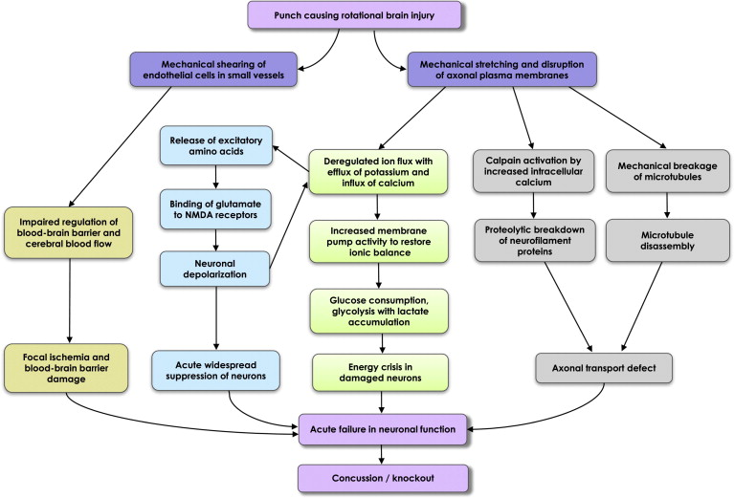

- Figure shows the development process, retrieved from The Neuropathology and Neurobiology of Traumatic Brain Injury.

Figure 2
$$F_{c}=m\frac{∆V}{∆T}$$
Fastest Collision
$$F_{C1}=1.4\frac{9.83-0}{.1-0}$$
$$F_{C1}=137.62 N$$
Medium Speed Collision
$$F_{C2}=1.4\frac{5-0}{.1-0}$$
$$F_{C2}=70N$$
Slowest Collision
$$F_{C3}=1.4\frac{1-0}{.1-0}$$
$$F_{C3}=14N$$
m represents the mass of the brain
∆V represents the change in velocity in meters per second
∆T represents the change in time during impact
- This figure represents the algebraic function of force collision and the math that used from each function of speed.
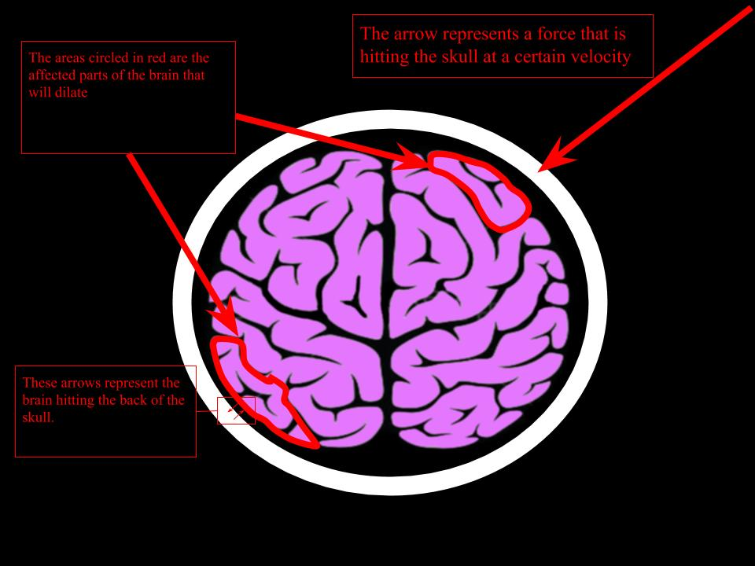
Figure 3

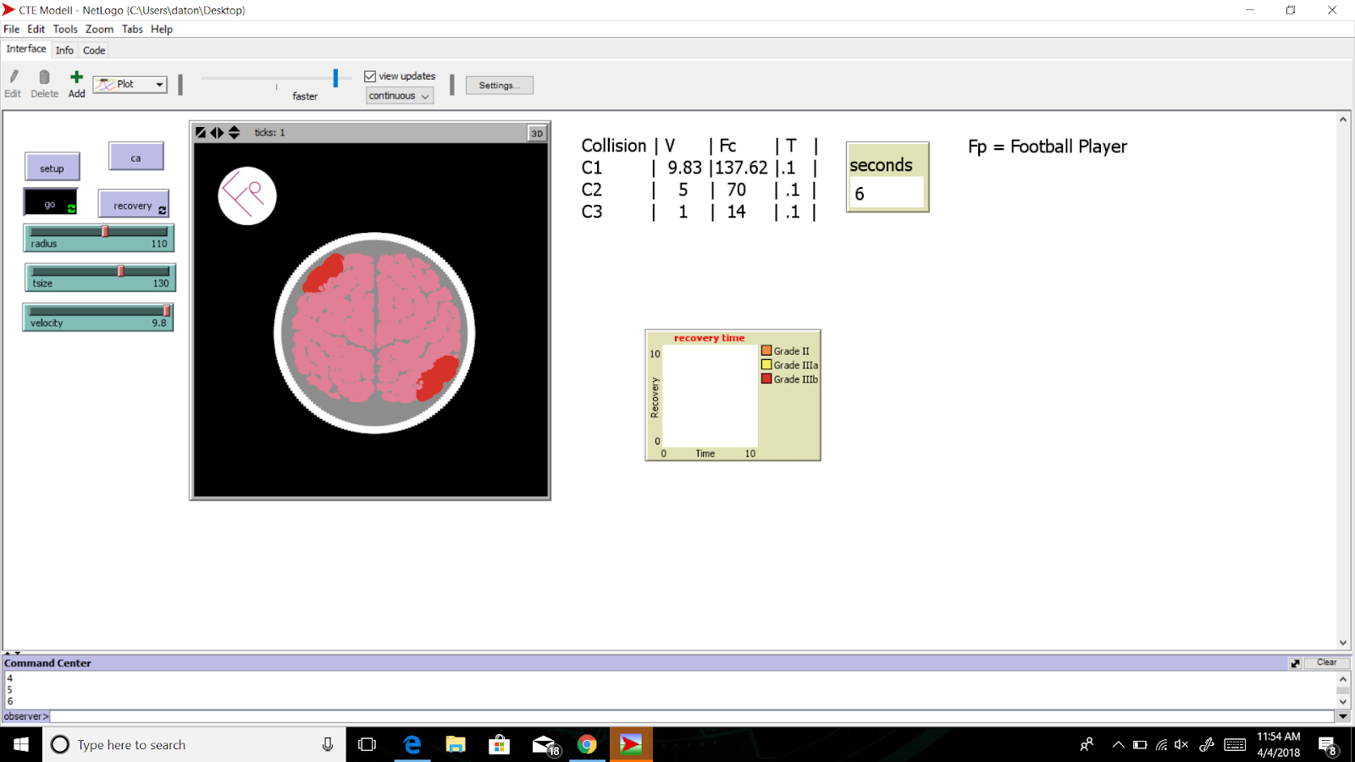
This figure has the model of the force diagram (top), and the result of the brain’s collision and swelling (bottom). The bottom also shows the output diagram and display
- Significant Achievements
  - Modeling CTE and showing a solution that works well. The info gathered from the sources gives an idea of the recovery time needed for certain concussions. The team used Grade 3a and 3b, since these concussion grades are the more serious and most relevant to the project.
- Acknowledgments
  - The mentor that assisted us with physics: Andrew Leonard
Andrew Leonard helped us simplify the collision equation in physics to simpler, algebraic terms that are easier to understand. These equations were applied to the final project, the team would like to thank Mr. Leonard for his patience and assistance to the final project. He also was able to help us find constants that can be applied to the function of force collision. The physics were hard to grasp until he helped clarify it.
  - The mentor that assisted us with code: Nick Bennett
Nick Bennett was kind enough to assist us in the radius function of the code. The team asked for assistance at late hours, and he kind enough to answer the questions, and advise the team about how to make the code function well. The programmers are very thankful for his help.
  - The teacher of the class: Tracy Galligan
Tracy Galligan was kind enough to allowed the team to stay after school to work on this project until late hours into the night and motivated the team to keep going even in the hardest parts of the process. She was encouraging in the right moments and kept the team’s priorities focused.
The team would like to thank all of these people for their assistance and encouragement.
Resources:
- Frequently Asked Questions about CTE. Retrieved December 10, 2017, from
https://www.bu.edu/cte/about/frequently-asked-questions/
- Jordan, B. D. (2013, March 12). The clinical spectrum of sport-related traumatic brain
injury. Retrieved December 10, 2017, from
https://www.nature.com/articles/nrneurol.2013.33
- The Neuropathology and Neurobiology of Traumatic Brain Injury. (2012, December 05).
Retrieved December 10, 2017, from
http://www.sciencedirect.com/science/article/pii/S0896627312010367
- Neuropsychological Test Performance Prior To and Following...: Clinical Journal of
Sport Medicine. (n.d.). Retrieved December 11, 2017, from
http://journals.lww.com/cjsportsmed/Abstract/2001/01000/Neuropsychological_
est_Performance_Prior_To_and.5.aspx
- Head, B. and Wilensky, U. (2013). NetLogo Membrane Formation model.
http://ccl.northwestern.edu/netlogo/models/MembraneFormation. Center for
Connected Learning and Computer-Based Modeling, Northwestern University,
Evanston, IL. Wilensky, U. (1999). NetLogo. http://ccl.northwestern.edu/netlogo/.
Center for Connected Learning and Computer-Based Modeling, Northwestern
University, Evanston, IL.
- Shuttershock. (n.d.). Outline top view illustration of human brain isolated on white background. Retrieved April 04, 2018, from
https://www.shutterstock.com/imagevector/outline-top-view-illustration-human-brain-420874276
- Fan, Judy. (2014, May 24). The Physics of Concussions. Retrieved April 3, 2018 from https://prezi.com/xyn4krle5eug/the-physics-of-concussions/

